Print Out Source Code Program

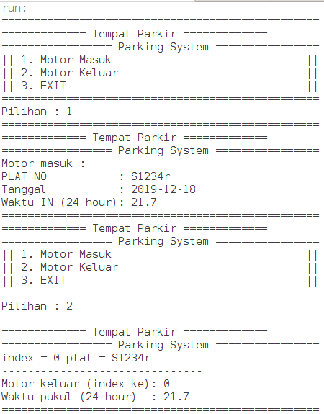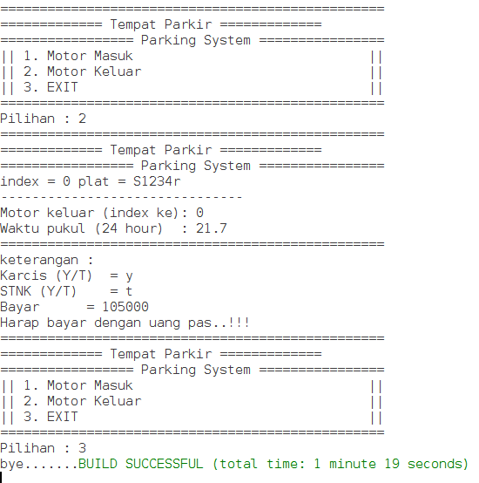

Keterangan Source Code :

------------------------------------------------------------------------------------------------------------------------------------------------------------------------------------------------------------------------------------------------------------------------------------------------------------------------------------------------------------------------------------------------------------------------------------------------------------------------------------------------------------------------------------------------------------------------------------------------------------------------------------------------------------------------------------------------------------------------------------------------------------------------------------------------------------------------------------------------------------------------------------------------------------------------------------------------------------------------------------------------------------------------------

Print Out Source Code Program

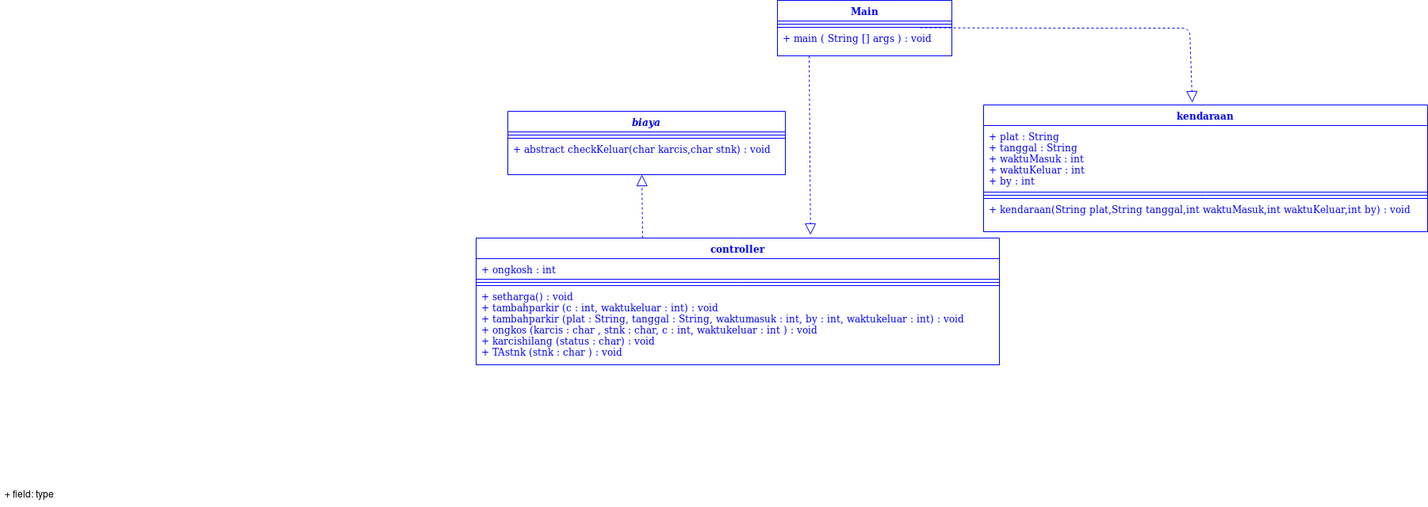

Keterangan Source Code :

------------------------------------------------------------------------------------------------------------------------------------------------------------------------------------------------------------------------------------------------------------------------------------------------------------------------------------------------------------------------------------------------------------------------------------------------------------------------------------------------------------------------------------------------------------------------------------------------------------------------------------------------------------------------------------------------------------------------------------------------------------------------------------------------------------------------------------------------------------------------------------------------------------------------------------------------------------------------------------------------------------------------------